PYTHON-4
TUPLE
1.Tuple
- Tuples are used to store multiple items in a single variable.
- A tuple is a collection which is ordered and unchangeable.

Tuple Items
- Tuple items are ordered(the items have a defined order, and that order will not change.), unchangeable(we cannot change, add or remove items after the tuple has been created), and allow duplicate values.
- Tuple items are indexed, the first item has index [0], the second item has index [1] etc.
- the len() function – calculate length of tuple
- To create a tuple with only one item, you have to add a comma after the item, otherwise Python will not recognize it as a tuple
- Tuple items can be of any data type
- tuple constructorIt is also possible to use the tuple() constructor to make a tuple
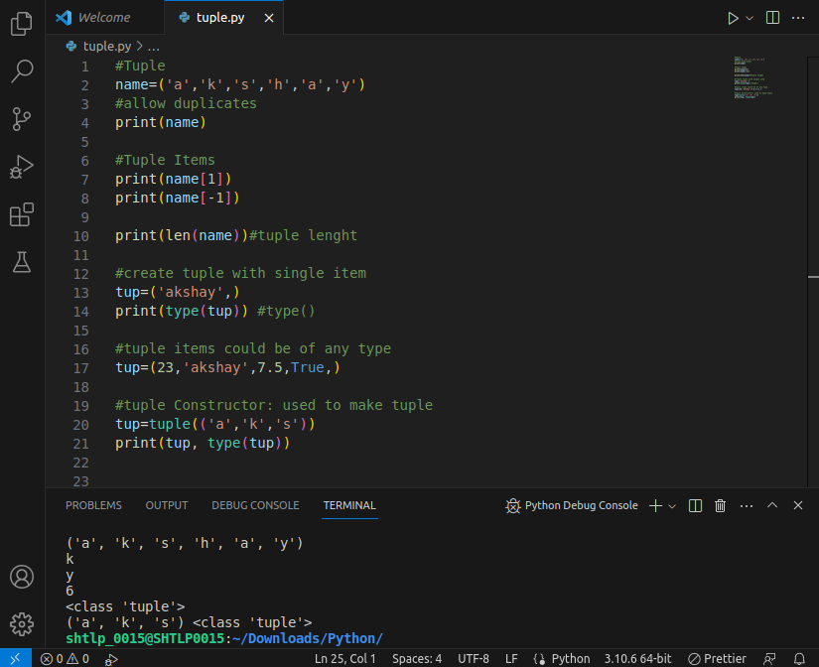

2. Access Tuple Items
- access tuple items by referring to the index number, inside square brackets
- Negative indexing means start from the end. -1 refers to the last item, -2 refers to the second last item etc.
- specifying a range, the return value will be a new tuple with the specified items
- By leaving out the start value, the range will start at the first item:
- By leaving out the end value, the range will go on to the end of the list:
- Specify negative indexes if you want to start the search from the end of the tuple
- To determine if a specified item is present in a tuple use the in keyword:
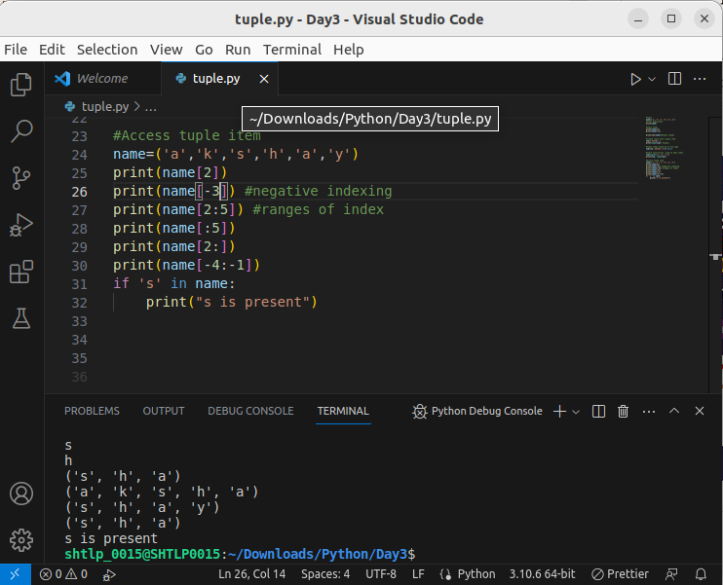

3.Update Tuple
- Tuples are unchangeable, meaning that you cannot change, add, or remove items once the tuple is created.
- You can convert the tuple into a list, change the list, and convert the list back into a tuple

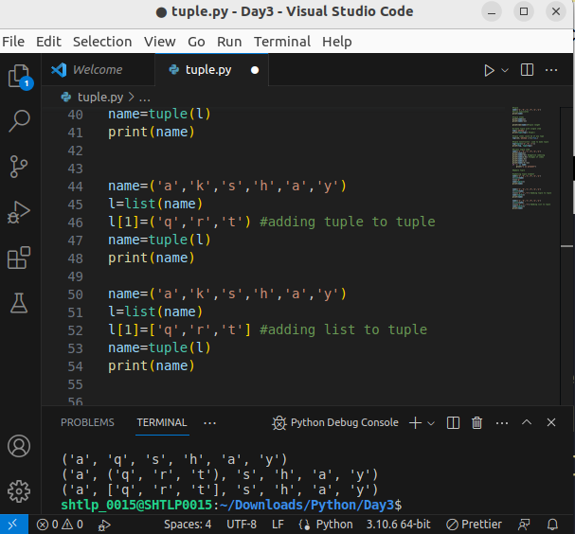
Add Items
- Convert into a list: we can convert it into a list, add your item(s), and convert it back into a tuple
- Add tuple to a tuple. You are allowed to add tuples to tuples, so if you want to add one item, (or many), create a new tuple with the item(s), and add it to the existing tuple
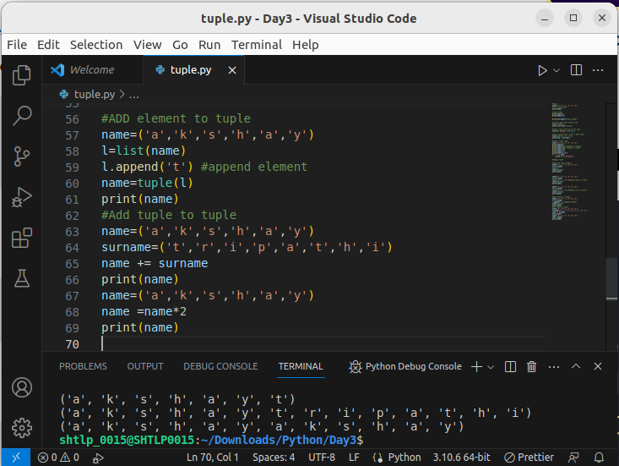

Remove Items
- Convert the tuple into a list, remove "element", and convert it back into a tuple
- The del keyword can delete the tuple completely

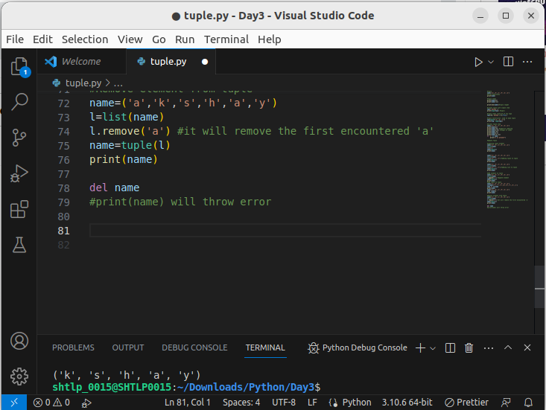
.

4. Unpacking a Tuple
- When we create a tuple, we normally assign values to it. This is called "packing" a tuple
- But, in Python, we are also allowed to extract the values back into variables. This is called "unpacking":
- The number of variables must match the number of values in the tuple, if not, you must use an asterisk to collect the remaining values as a list
- If the asterisk is added to another variable name than the last, Python will assign values to the variable until the number of values left matches the number of variables left
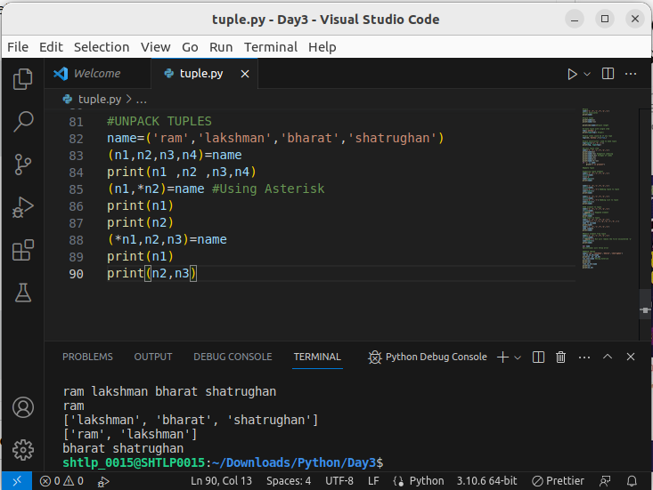
.

5.Python Tuple Looping
- the tuple items by using a for loop.
- We can also loop through the tuple items by referring to their index number. Use the range() and len() functions to create a suitable iterable
- While loop :Use the len() function to determine the length of the tuple, then start at 0 and loop your way through the tuple items by referring to their indexes.Remember to increase the index by 1 after each iteration.
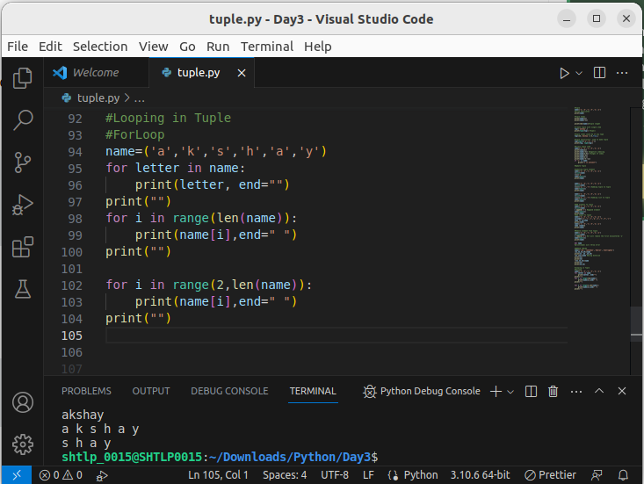
.
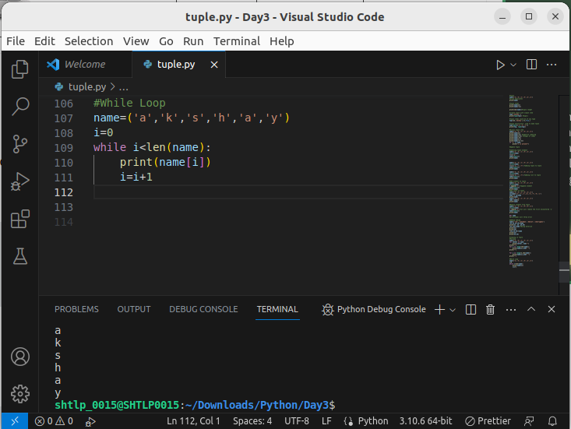
.

6.Join Tuple
- To join two or more tuples you can use the + operator:
- If you want to multiply the content of a tuple a given number of times, you can use the * operator:
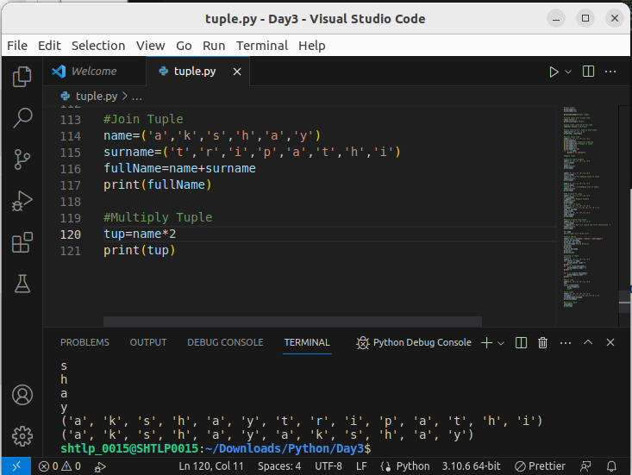
.

7. Tuple Method
count()
The count() method returns the number of times a specified value appears in the tuple
index()
Searches the tuple for a specified value and returns the position of where it was found

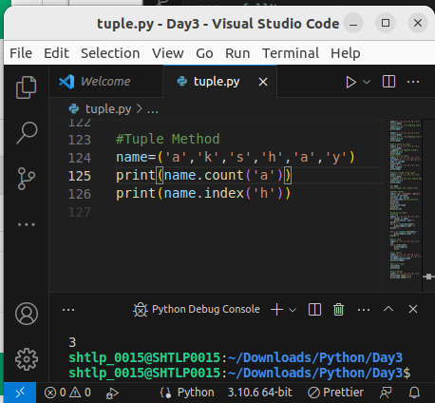

SET
1.Pyhton SET
- A set is a collection which is unordered, unchangeable*, and unindexed
- Set items are unchangeable, but you can remove items and add new items
- Unordered means that the items in a set do not have a defined order.Set items can appear in a different order every time you use them, and cannot be referred to by index or key.
- Set items are unchangeable, meaning that we cannot change the items after the set has been created.
- Duplicate items are not allowed Sets cannot have two items with the same value
- To determine how many items a set has, use the len() function.
- Set items can be of any data type
- type() : <class 'set'>
- t is also possible to use the set() constructor to make a set
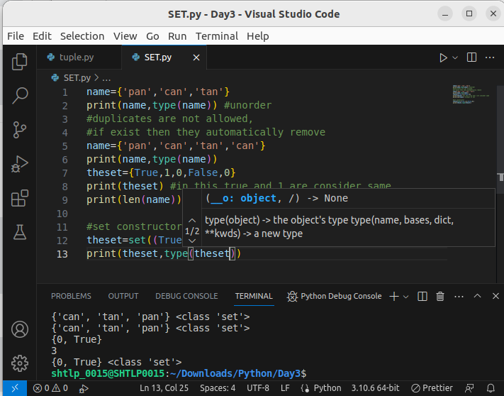

2. Access Set Item
- You cannot access items in a set by referring to an index or a key.
- But you can loop through the set items using a for loop, or ask if a specified value is present in a set, by using the in keyword.
- Once a set is created, you cannot change its items, but you can add new items.

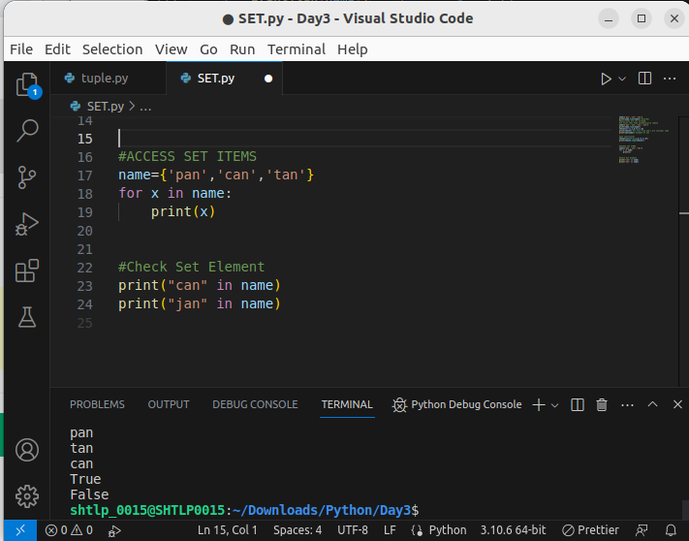
.
3.Add Set Items
- To add one item to a set use the add() method
- To add items from another set into the current set, use the update() method.
- The object in the update() method does not have to be a set, it can be any iterable object (tuples, lists, dictionaries etc
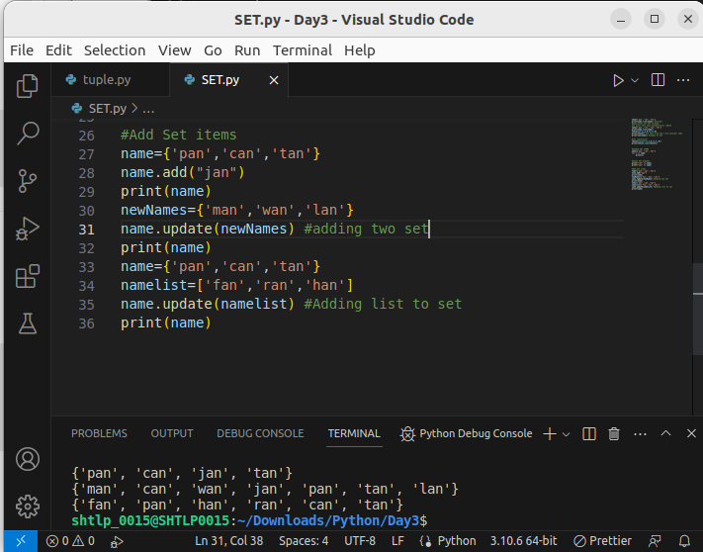
.
4.Remove Set Item
- to remove an item in a set, use the remove(), or the discard() method.
- If the item to remove does not exist, remove() will raise an error.
- If the item to remove does not exist, discard() will NOT raise an error.
- can also use the pop() method to remove an item, but this method will remove a random item, so you cannot be sure what item that gets removed.
- The return value of the pop() method is the removed item.
- Sets are unordered, so when using the pop() method, you do not know which item that gets removed.
- The clear() method empties the set
- The del keyword will delete the set completely
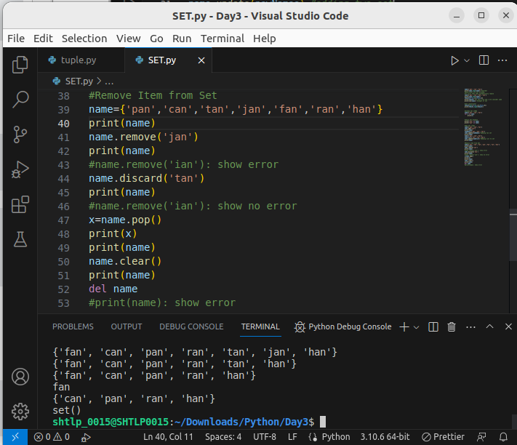
.
5.Loop Set
- loop through the set items by using a for loop
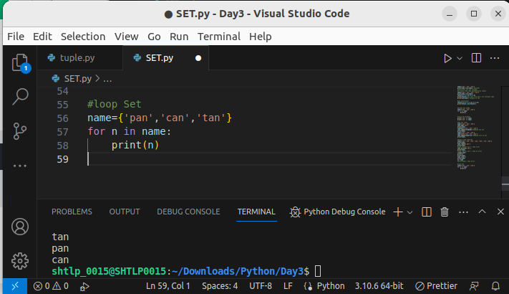
6. Join Set
- use the union() method that returns a new set containing all items from both sets, or the update() method that inserts all the items from one set into another:
- The union() method returns a new set with all items from both sets
- The update() method inserts the items in set2 into set1
- Both union() and update() will exclude any duplicate items
- The intersection_update() method will keep only the items that are present in both sets.
- The intersection() method will return a new set, that only contains the items that are present in both sets.
- The symmetric_difference_update() method will keep only the elements that are NOT present in both sets.
- The symmetric_difference() method will return a new set, that contains only the elements that are NOT present in both sets.
- The values True and 1 are considered the same value in sets, and are treated as duplicates:
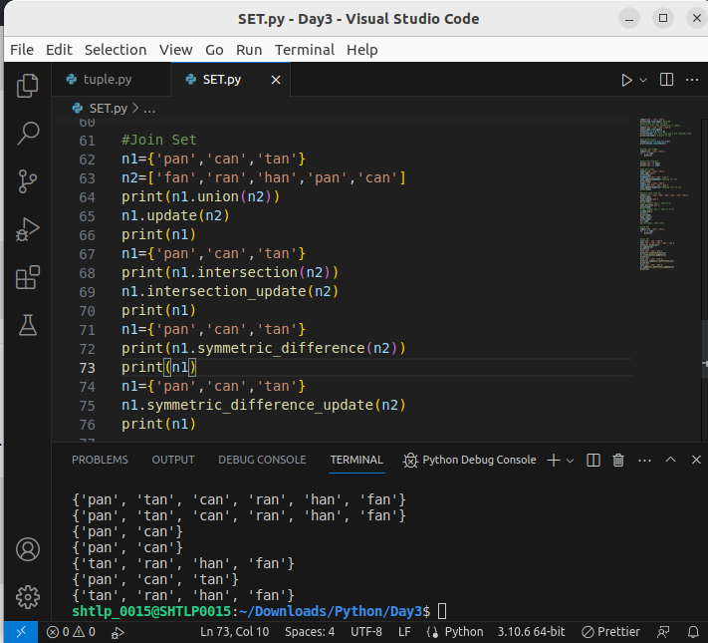
.
7.Set Method
- copy(): The copy() method copies the set.
- issubset():The issubset() method returns True if all items in the set exists in the specified set, otherwise it returns False.
- The issuperset() method returns True if all items in the specified set exists in the original set, otherwise it returns False.
- The isdisjoint() method returns True if none of the items are present in both sets, otherwise it returns False.
